**First model run: sfbay_1.png**

The model correctly identified 10 ships in the scene and misclassified 4 areas – 2 of land as ships (Fig 1, Fig 4) and 2 sections of piers as ships (Fig 2, Fig 3). This visual check gives us an **accuracy of ship classification of** **71%**. This misclassification has been verified through a visual check of more recent imagery available for the same area of interest in Google Maps (Fig 5, Fig 6).

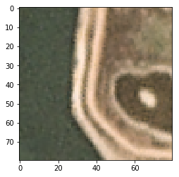

Figure : X:2400 Y:0 [[0.04527112 0.9547289 ]]

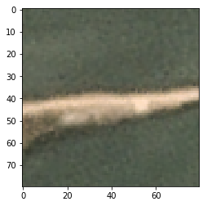

Figure 2: X:1320 Y:1650 [[0.04042681 0.9595732 ]]

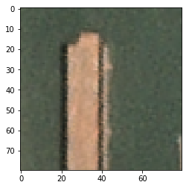

Figure : X:960 Y:690 [[0.0869388 0.9130612]]

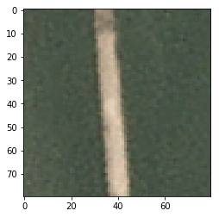

Figure : X:1010 Y:780 [[0.0022693 0.9977307]]

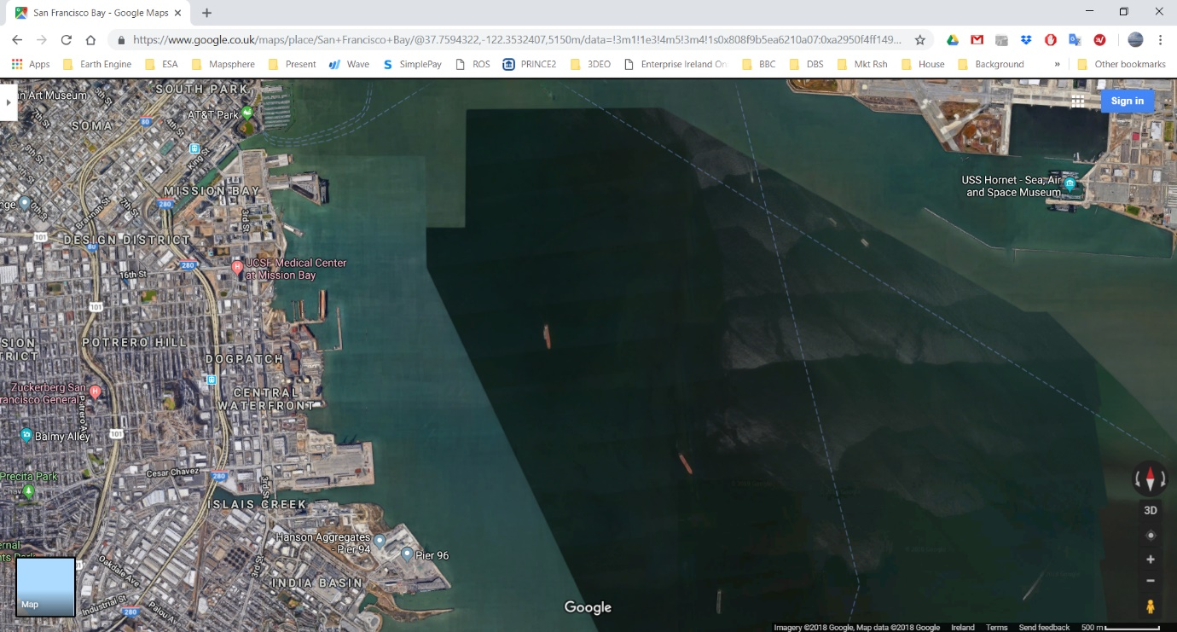

Figure : Same AOI checked on Google Maps to ground truth the model classification

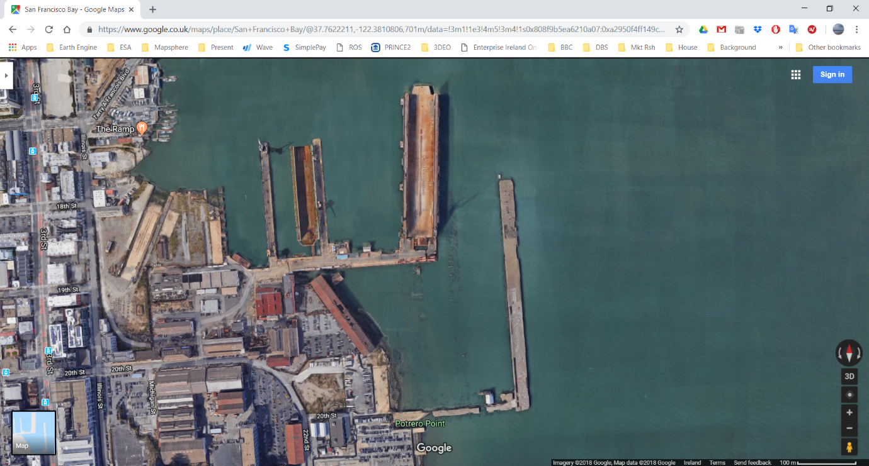

Figure : Close up of the two piers misclassified as ships with an accuracy of >0.99

**Second model run: sfbay_2.png**

The model correctly identified 9 ships in the scene and misclassified 9 areas – 2 of land as ships (Fig 7, Fig 8) and 7 sections of piers as ships (Fig 9 - Fig 14). This visual check gives us an **accuracy of ship classification of 50%**. This misclassification has been verified through a visual check of more recent imagery available for the same area of interest in Google Maps (Fig 16).

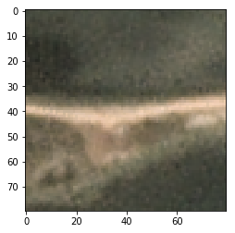

Figure : X:1220 Y:130 [[0.03308497 0.9669151 ]]

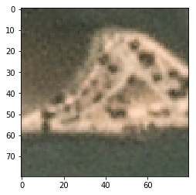

Figure : X:1060 Y:1210 [[0.09733345 0.9026665 ]]

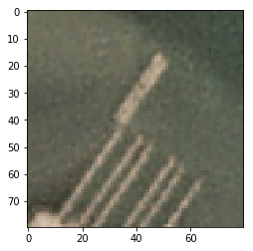

Figure : X:1370 Y:310 [[0.05465791 0.94534206]]

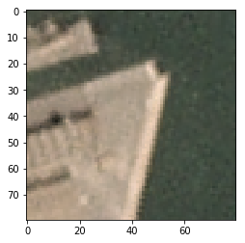

Figure : X:1610 Y:490 [[0.05329443 0.9467055 ]]

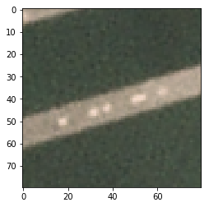

Figure : X:1550 Y:630 [[0.0041544 0.9958456]]

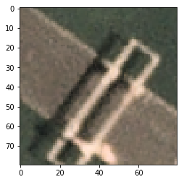

Figure : X:1500 Y:790 [[0.09521437 0.90478563]]

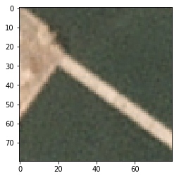

Figure : X:1480 Y:880 [[0.03763811 0.9623619 ]]

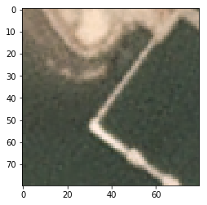

Figure : X:1390 Y:960 [[0.03541527 0.96458477]]

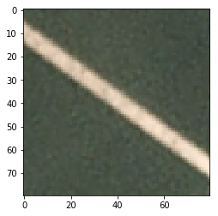

Figure : X:1490 Y:970 [[6.716660e-04 9.993284e-01]]

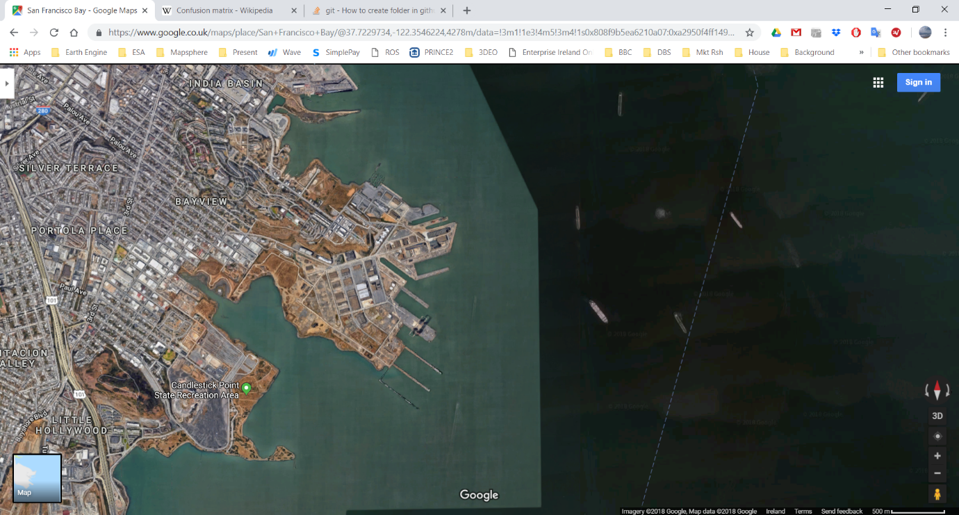

Figure : Same AOI checked on Google Maps to ground truth the model classification

**Third model run: sfbay_3.png**

The model correctly identified 11 ships in the scene and misclassified 14 areas – 6 of land as ships (Fig 17 - Fig 21) and 8 sections of piers as ships (Fig 22 - Fig 30). This visual check gives us an **accuracy of ship classification of 44%**. This misclassification has been verified through a visual check of more recent imagery available for the same area of interest in Google Maps (Fig 16).

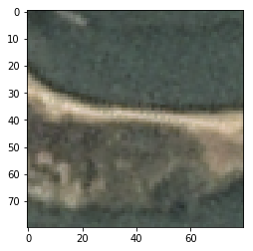

Figure : X:740 Y:250 [[0.054497 0.94550306]]

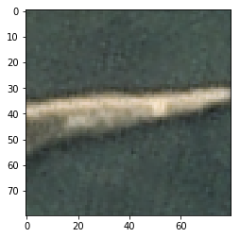

Figure : X:830 Y:250 [[0.01934687 0.98065317]]

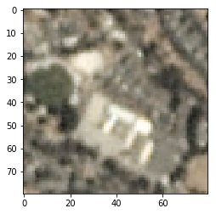

Figure : X:440 Y:450 [[0.09366554 0.9063345 ]]

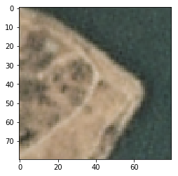

Figure : X:1130 Y:1060 [[0.01401125 0.98598874]]

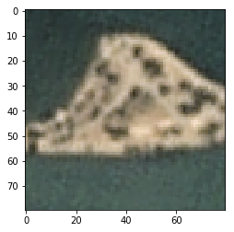

Figure : X:630 Y:1330 [[0.07275792 0.9272421 ]]

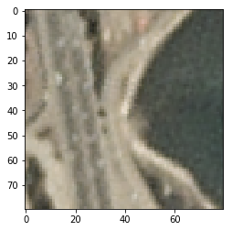

Figure : X:100 Y:1390 [[0.09705466 0.90294534]]

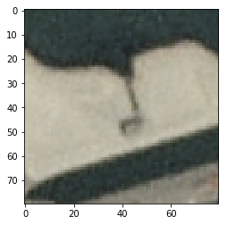

Figure : X:1070 Y:560 [[0.07756016 0.9224399 ]]

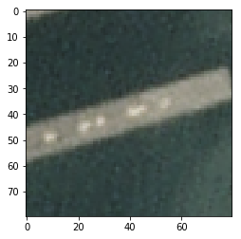

Figure : X:1120 Y:750 [[0.07447767 0.9255224 ]]

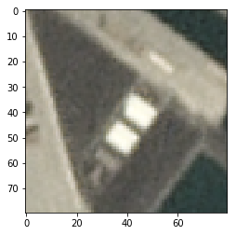

Figure : X:990 Y:910 [[0.09853239 0.9014676 ]]

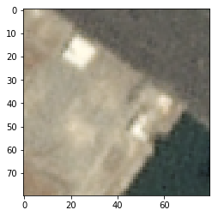

Figure : X:990 Y:910 [[0.09853239 0.9014676 ]]

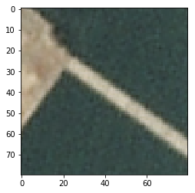

Figure : X:1040 Y:1000 [[0.01527637 0.9847237 ]]

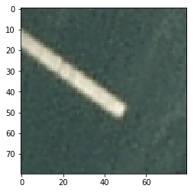

Figure : X:1130 Y:1060 [[0.01401125 0.98598874]]

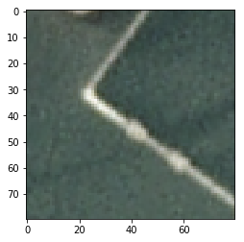

Figure : X:960 Y:1100 [[0.01216436 0.9878356 ]]

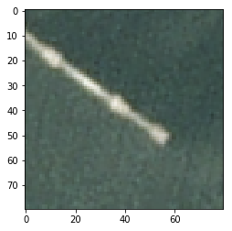

Figure : X:1050 Y:1170 [[0.01977644 0.98022354]]

**Fourth model run: sfbay_4.png**

The model correctly identified X ships in the scene and misclassified X areas – X of land as ships (Fig X, Fig X) and X sections of piers as ships (Fig X, Fig X). This misclassification has been verified through a visual check of more recent imagery available for the same area of interest in Google Maps (Fig 5, Fig 6).